**Lab Tasks:**

1. **Find all customer related information who have an account in a branch, located in the same city as they live. (write this query without using subqueries and then using a subquery)**

-- Without subquery

SELECT DISTINCT c.customer_name, c.customer_street, c.customer_city

FROM customer c

JOIN depositor d ON c.customer_name = d.customer_name

JOIN account a ON d.account_number = a.account_number

JOIN branch b ON a.branch_name = b.branch_name

WHERE c.customer_city = b.branch_city;

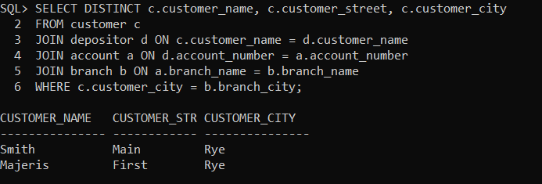

-- With subquery

SELECT customer_name, customer_street, customer_city

FROM customer

WHERE customer_name IN (

SELECT d.customer_name

FROM depositor d

JOIN account a ON d.account_number = a.account_number

JOIN branch b ON a.branch_name = b.branch_name

WHERE b.branch_city = (

SELECT customer_city

FROM customer

WHERE customer_name = d.customer_name

)

);

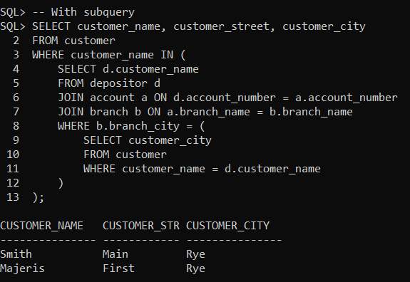

1. **Find all customer related information who have a loan in a branch, located in the same city as they live. (write this query without using subqueries and then using a subquery)**

-- Without subquery

SELECT DISTINCT C.*

FROM Customer C

JOIN Borrower BO ON C.customer_name = BO.customer_name

JOIN Loan L ON BO.loan_number = L.loan_number

JOIN Branch B ON L.branch_name = B.branch_name

WHERE C.customer_city = B.branch_city;

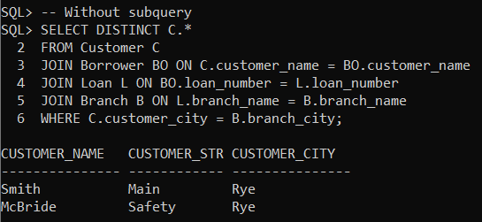

-- With subquery

SELECT *

FROM Customer C

WHERE C.customer_name IN (

    SELECT BO.customer_name

    FROM Borrower BO

    JOIN Loan L ON BO.loan_number = L.loan_number

    JOIN Branch B ON L.branch_name = B.branch_name

    WHERE C.customer_city = B.branch_city

);

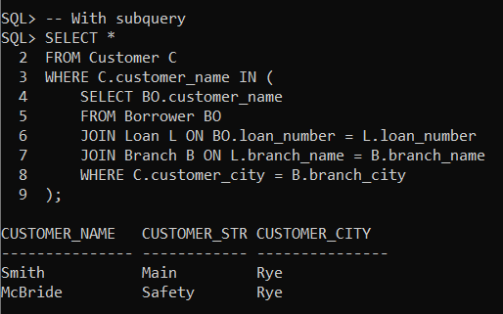

1. **For each branch city, find the average balance of all the accounts opened in a branch located in that branch city. Do not include any branch city in the result where the total balance of all accounts opened in a branch located in that city is less than 1000. (Write this query with and without using ‘having’ clause)**

-- Without HAVING clause

SELECT B.branch_city, AVG(A.balance) AS avg_balance

FROM Account A

JOIN Branch B ON A.branch_name = B.branch_name

WHERE B.branch_city NOT IN (

SELECT B2.branch_city

FROM Account A2

JOIN Branch B2 ON A2.branch_name = B2.branch_name

GROUP BY B2.branch_city

HAVING SUM(A2.balance) < 1000

)

GROUP BY B.branch_city;

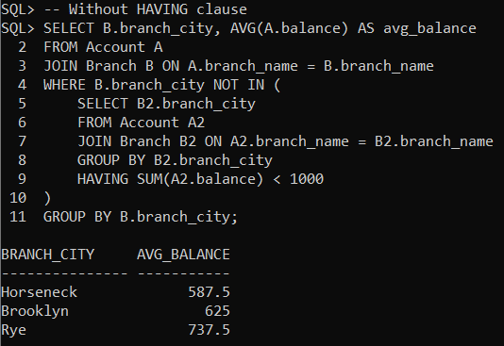

-- With HAVING clause

SELECT B.branch_city, AVG(A.balance) AS avg_balance

FROM Account A

JOIN Branch B ON A.branch_name = B.branch_name

GROUP BY B.branch_city

HAVING SUM(A.balance) >= 1000;

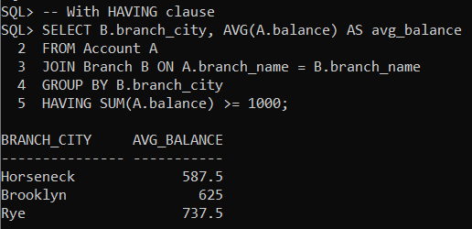

1. **For each branch city, find the average amount of all the loans opened in a branch located in that branch city. Do not include any branch city in the result where the average amount of all loans opened in a branch located in that city is less than 1500. (write this query with and without using ‘having’ clause)**

-- Without HAVING clause

SELECT B.branch_city, AVG(L.amount) AS avg_loan

FROM Loan L

JOIN Branch B ON L.branch_name = B.branch_name

WHERE B.branch_city NOT IN (

SELECT B2.branch_city

FROM Loan L2

JOIN Branch B2 ON L2.branch_name = B2.branch_name

GROUP BY B2.branch_city

HAVING AVG(L2.amount) < 1500

)

GROUP BY B.branch_city;

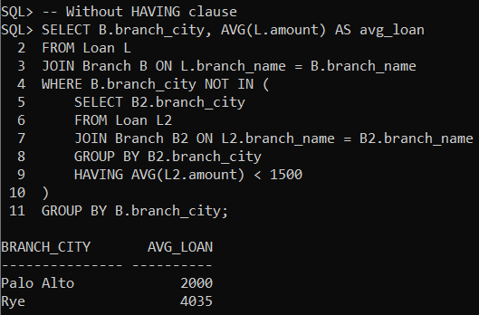

-- With HAVING clause

SELECT B.branch_city, AVG(L.amount) AS avg_loan

FROM Loan L

JOIN Branch B ON L.branch_name = B.branch_name

GROUP BY B.branch_city

HAVING AVG(L.amount) >= 1500;

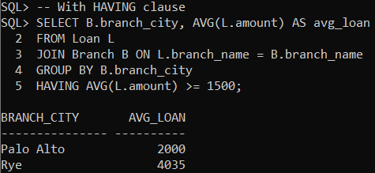

1. **Find the customer name, customer street, customer city of the account which has the highest balance among all the accounts. (Write this query with and without using all keyword)**

-- Without using ALL keyword:

SELECT c.customer_name, c.customer_street, c.customer_city

FROM customer c

JOIN depositor d ON c.customer_name = d.customer_name

JOIN account a ON d.account_number = a.account_number

WHERE a.balance = (SELECT MAX(balance) FROM account);

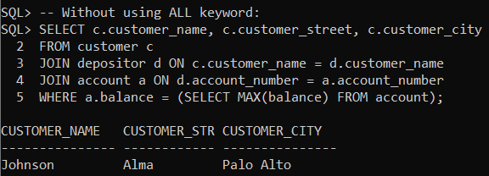

-- Using ALL keyword:

SELECT c.customer_name, c.customer_street, c.customer_city

FROM customer c

JOIN depositor d ON c.customer_name = d.customer_name

JOIN account a ON d.account_number = a.account_number

WHERE a.balance >= ALL (SELECT balance FROM account);

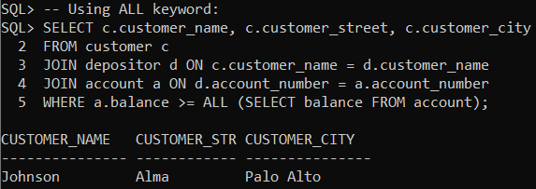

1. **Find the customer name, customer street, customer city of the loan which has the lowest amount among all the loans. (write this query with and without using all keyword)**

-- With ALL:

SELECT C.customer_name, C.customer_street, C.customer_city

FROM Customer C

JOIN Borrower BO ON C.customer_name = BO.customer_name

JOIN Loan L ON BO.loan_number = L.loan_number

WHERE L.amount <= ALL (SELECT amount FROM Loan);

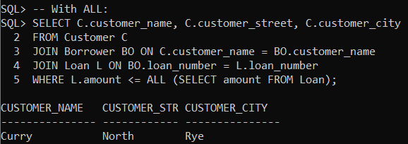

-- Without ALL:

SELECT C.customer_name, C.customer_street, C.customer_city

FROM Customer C

JOIN Borrower BO ON C.customer_name = BO.customer_name

JOIN Loan L ON BO.loan_number = L.loan_number

WHERE L.amount = (SELECT MIN(amount) FROM Loan);

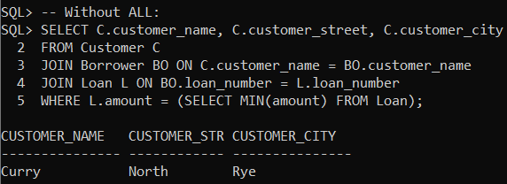

1. **Find the distinct branches (name and city) that have opened both accounts and loans. (Write this query using in and exists keyword)**

-- Using Exists

SELECT DISTINCT B.branch_name, B.branch_city

FROM Branch B

WHERE EXISTS (

SELECT 1 FROM Account A WHERE A.branch_name = B.branch_name

)

AND EXISTS (

SELECT 1 FROM Loan L WHERE L.branch_name = B.branch_name

);

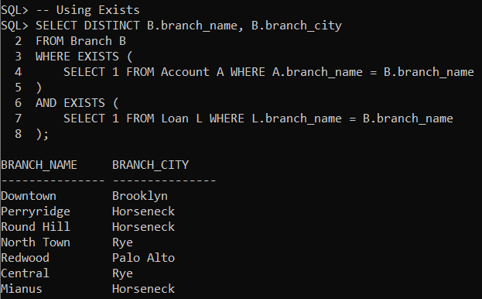

-- Using IN

SELECT branch_name, branch_city

FROM branch

WHERE branch_name IN (SELECT branch_name FROM account)

  AND branch_name IN (SELECT branch_name FROM loan);

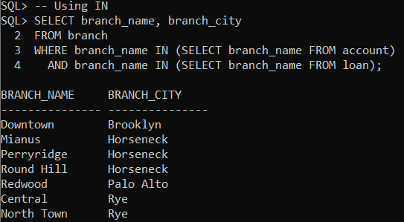

1. **Find the distinct customers (name and city) who do not have loans but have accounts. (write this query using not in and not exists keyword)**

-- Using NOT IN keyword:

SELECT DISTINCT c.customer_name, c.customer_city

FROM customer c

WHERE c.customer_name IN (

SELECT customer_name FROM depositor

) AND c.customer_name NOT IN (

SELECT customer_name FROM borrower

);

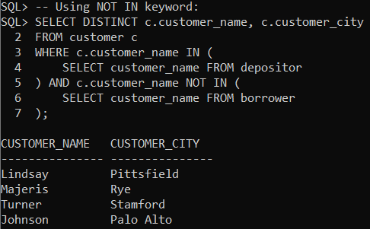

-- Using NOT EXISTS keyword:

SELECT DISTINCT c.customer_name, c.customer_city

FROM customer c

WHERE EXISTS (

    SELECT 1 FROM depositor d WHERE d.customer_name = c.customer_name

) AND NOT EXISTS (

    SELECT 1 FROM borrower b WHERE b.customer_name = c.customer_name

);

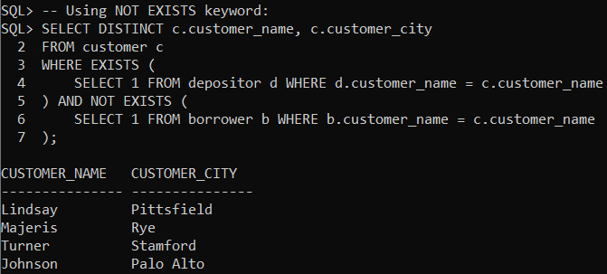

1. **Find those branch names which have total account balance greater than the average of total balance among all the branches. (write this query with and without using with clause)**

-- With clause

WITH Avg_Balance AS (

SELECT AVG(balance) AS overall_avg_balance

FROM Account

)

SELECT DISTINCT B.branch_name

FROM Account A

JOIN Branch B ON A.branch_name = B.branch_name

WHERE A.balance > (SELECT overall_avg_balance FROM Avg_Balance);

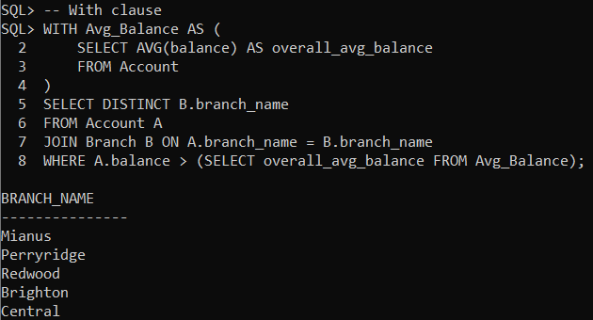

-- Without clause

SELECT DISTINCT B.branch_name

FROM Account A

JOIN Branch B ON A.branch_name = B.branch_name

WHERE A.balance > (

    SELECT AVG(balance)

    FROM Account

);

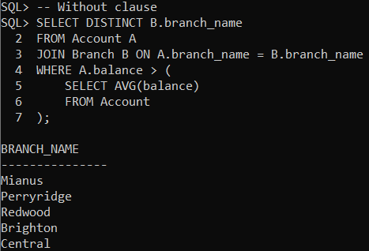

1. **Find those branch names which have total loan amount less than the average of total loan amount among all the branches. (write this query with and without using with clause)**

-- With clause

WITH Avg_Loan AS (

SELECT AVG(amount) AS overall_avg_loan

FROM Loan

)

SELECT DISTINCT B.branch_name

FROM Loan L

JOIN Branch B ON L.branch_name = B.branch_name

GROUP BY B.branch_name

HAVING SUM(L.amount) < (SELECT overall_avg_loan FROM Avg_Loan);

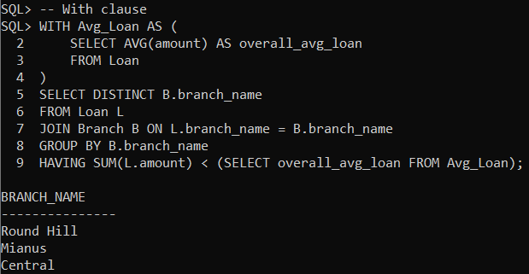

-- Without clause

SELECT DISTINCT B.branch_name

FROM Loan L

JOIN Branch B ON L.branch_name = B.branch_name

GROUP BY B.branch_name

HAVING SUM(L.amount) < (

    SELECT AVG(amount)

    FROM Loan

);

